New Hampshire Homeowner Assistance Fund Plan
Executive Summary

On March 11, 2021, the President of the United States signed into law the American Rescue Plan Act (ARPA). The ARPA directs the United States Department of Treasury (US Treasury) to allocate and make payments to States based on homeowner need as of the date of the enactment. Based upon the data and methodology used by the US Treasury, the State of New Hampshire will receive $50,000,000 from the Homeowner Assistance Fund (HAF). The New Hampshire Governor’s Office for Emergency Relief and Recovery (GOFERR) has contracted with the New Hampshire Housing Finance Authority (New Hampshire Housing) to administer those funds.

Due to the coronavirus pandemic, the homeowners of New Hampshire are facing a number of financial hardships ranging from mortgage delinquencies, foreclosure, to loss of major utilities. The HAF was established to mitigate those hardships.

New Hampshire Housing has worked diligently to identify programs that will be the most beneficial and offer the quickest solutions to ensure homeowners are not displaced. New Hampshire Housing has collected and reviewed data as it relates to the unemployment rate for the state and the default of mortgages, property taxes, and utilities. New Hampshire Housing has also received input on the program’s design from key stakeholders throughout New Hampshire.

As a result, New Hampshire Housing has developed three initial programs to assist in curing mortgage, property charge, and utility/internet defaults and has also dedicated funding to housing counselors and legal services. New Hampshire Housing will be reassessing the need for additional programs, or changes in current programs, continually from the launch. Specifically, New Hampshire Housing will conduct a review every three months. New Hampshire Housing will determine whether any changes need to be made to eligibility requirements, the document submission process, program maximums, or if there is a need to establish additional programs. New Hampshire Housing is committed to helping resolve defaults that threaten a homeowner’s ability to sustain property ownership.

For all HAF Programs:

- The maximum amount of HAF funds per household will be $20,000.
- Consistent with US Treasury guidance, all eligible applicants will be required to seek loss mitigation options with their servicer prior to receiving HAF funds; however, an exception clause is in place for those:
  - Whose servicer has not been timely and responsive with a homeowner’s loss-mitigation efforts;
  - Who have demonstrated imminent threat of losing their home, which makes it unlikely that loss mitigation can be completed in time; or
  - Who for other good cause when other extenuating circumstances outside of the homeowner’s control prevent completion of loss mitigation.

HAF Proposed Programs

Mortgage Loan Reinstatement Program – will be a one-time payment program to bring delinquent mortgage loans current up to a $20,000 cap. Homeowners will be required to show that they suffered a financial hardship due to the coronavirus pandemic after January 21, 2020 or one that began prior to but continued after January 21, 2020, had incomes at or below 125% AMI at the time of hardship, and that they have the ability to make their payments moving forward. Any applicant not able to show the ability to make future payments will be referred for pre-foreclosure counseling with a HUD-certified counseling agency.

If the cumulative total amount of assistance for any or all programs exceeds $5,000, then the assistance will be restructured as a two-year forgivable grant. The grant will be due in full upon sale, cash-out refinance, or transfer of ownership. If no resale, refinance, or transfer of ownership occurs within two years, the grant will be fully forgiven. If the amount of assistance is less than $5,000, then assistance will be in the form of a non-recourse grant.

Property Charge Default Resolution Program – will be a one-time payment program to pay any past due property taxes, insurance (fire, hazard, or flood) payments, association dues, and lot rents up to a $20,000 cap. Reasonable late fees, interest, and legal fees may be considered in the amount of arrearage if the party owed these fees has first attempted to exhaust all options to waive or reduce them. Homeowners will be required to show that they suffered a financial hardship due to the coronavirus pandemic after January 21, 2020 or one that began prior to but continued after January 21, 2020 and had incomes at or below 125% AMI at the time of hardship.

If the cumulative total amount of assistance for any or all programs exceeds $5,000, then the assistance will be restructured as a two-year forgivable grant. The grant will be due in full upon sale, cash-out refinance, or transfer of ownership. If no resale, refinance, or transfer of ownership occurs within two years the grant will be fully forgiven. If the amount of assistance is less than $5,000, then assistance will be in the form of a non-recourse grant.

Utility/Internet Payment Assistance Program – will be a one-time payment program to pay any past due utility payments in full. This program will have a maximum $3,000 cap. Internet payments will be provided at a maximum benefit amount of $50.00 per month, up to the $3,000 limit. Reasonable late fees, interest, and legal fees may be considered in the amount of arrearage if the party owed these fees has first attempted to exhaust all options to waive or reduce them. Homeowners will be required to show that they suffered a financial hardship due to the coronavirus pandemic after January 21, 2020 or one that began prior to but continued after January 21, 2020 and had incomes at or below 125% AMI at the time of hardship. Assistance less than $5,000 will be in the form of a non-recourse grant.

If the cumulative total amount of assistance for any or all programs exceeds $5,000, then the assistance will be restructured as a two-year forgivable grant. The grant will be due in full upon sale, cash-out refinance, or transfer of ownership. If no resale, refinance, or transfer of ownership occurs within two years the grant will be fully forgiven.

Housing Counseling and Legal Aid Services

US Treasury guidance allows the State to use up to 5% of a State’s HAF allocation for housing counseling and/or legal services to assist eligible homeowners.

Counseling Services – no more than 2.5% ($1,250,000) of HAF will be allocated to Housing Counseling Services to assist homeowners with pre-foreclosure counseling.

Legal Aid Services – no more than 2.5% ($1,250,000) of HAF will be allocated to Legal Aid Services to provide free in-state legal services to at-risk eligible homeowners.

HAF Outreach and Marketing

New Hampshire’s HAF outreach and marketing plan will include a designated webpage on the New Hampshire Housing website and a unique website that will prominently display HAF program information, as well as offer guidance and resources to individuals experiencing homeownership or rental housing instability. New Hampshire Housing will actively and regularly engage in HAF and related topics on social media, in news releases, and digital and print advertising, as well as other messaging channels such as PSAs and community outreach. In addition, New Hampshire Housing will leverage existing partnerships with mortgage servicers, lenders, Realtors, housing counseling organizations, community development corporations, and local offices as community navigators with an emphasis on low income, minority, and socially disadvantaged populations. Outreach and marketing materials will be made available in multiple languages.

New Hampshire Homeowner Assistance Fund

Disclaimer

This Homeowner Assistance Fund (HAF) Plan was submitted for approval to the U.S. Department of the Treasury (US Treasury) by the New Hampshire Governor’s Office for Emergency Relief and Recovery (GOFERR) on September 24, 2021.
On March 11, 2021, the President of the United States signed into law the American Rescue Plan Act (ARPA), which includes the Homeowner Assistance Fund. The State of New Hampshire will receive $50,000,000 from HAF, and New Hampshire Housing Finance Authority (New Hampshire Housing) has been designated by the state to administer the HAF Plan. US Treasury published Homeowner Assistance Fund Guidance on August 2, 2021 (HAF Guidance), which requires the state to submit a HAF Plan or provide the US Treasury with an estimated date by which a HAF plan will be submitted, no later than 14 days after the US Treasury portal becomes available. The US Treasury Portal was made available on Friday, August 6, 2021. The State submitted its HAF plan to US Treasury on September 24, 2021.
US Treasury has stated that the purpose of HAF is to prevent mortgage delinquencies and defaults, foreclosures, loss of utilities or home energy services, and displacement of homeowners experiencing financial hardship due to the coronavirus pandemic after January 21, 2020 or began prior to but continued after January 21, 2020. Funds from HAF may be used for assistance with mortgage defaults, mortgage payments, homeowner’s insurance, utility payments, and other specified purposes.
In accordance with law and US Treasury’s HAF Guidance, New Hampshire Housing developed a draft HAF Plan for submission to US Treasury, made the draft HAF Plan available for public comment, held a Public Hearing on September 8, 2021, and accepted public comments up until September 13, 2021.
This public hearing was attended by 41 individuals, representing 25 organizations, and 8 of the 10 different counties in New Hampshire. Of the organizations present, 44% primarily serve low to moderate income households and 60% directly address the impacts of housing discrimination.

Overview

On March 11, 2021, the President of the United States signed into law the American Rescue Plan Act (ARPA). ARPA appropriated $1.9 trillion in federal funding for the coronavirus pandemic related expenses and need. Section 3206 of ARPA established the Homeowner Assistance Fund (HAF), which provides approximately $9.9 billion in federal funds to states, territories, and tribal governments to assist low- and moderate-income homeowners who have experienced a negative financial impact associated with the coronavirus pandemic. ARPA directs the United States Department of Treasury (US Treasury) to allocate and make payments to states based on homeowner need as of the date of enactment. Based upon the data and methodology used by US Treasury, the State of New Hampshire will receive $50,000,000 from US Treasury for HAF. The Governor’s Office for Emergency Relief and Recovery (GOFERR) has contracted with New Hampshire Housing Finance Authority (New Hampshire Housing) to administer those funds.

Due to the pandemic, New Hampshire homeowners may be facing a number of financial hardships including mortgage delinquencies, foreclosures, and inability to make utility payments. HAF was established to mitigate those hardships. The Coronavirus Aid, Relief, and Economic Security (CARES) Act allowed many impacted homeowners to enter forbearance, pausing their monthly mortgage loan payments. Many New Hampshire homeowners took advantage of forbearance at the time of their hardship and are now exiting those plans, only to find that they have accrued tens of thousands of dollars in past due mortgage payments. HAF will provide much needed assistance to homeowners who are struggling to meet those financial obligations.

US Treasury published HAF initial Guidance on April 14, 2021, and then updated Guidance on August 2, 2021 (HAF Guidance) which requires the state to submit a HAF Plan or provide the US Treasury with an estimated date by which a HAF plan will be submitted no later than 14 days after the US Treasury portal becomes available. The US Treasury Portal was made available on Friday, August 6, 2021. The State submitted its HAF plan to US Treasury on September 24, 2021.

The following is the HAF Plan to be submitted to US Treasury. New Hampshire Housing will administer the $50,000,000 received through HAF to assist New Hampshire homeowners that were financial impacted by the coronavirus pandemic. New Hampshire Housing is submitting a New Hampshire Homeowner Assistance Fund Plan which will achieve goals set forth in the HAF Guidance, specifically to reduce mortgage loan delinquencies, defaults, foreclosures, and displacement of homeowners.

Homeowner Needs Assessment

Assessment Overview
This Needs Assessment and Plan (the Plan) outlines the homeownership landscape in New Hampshire and estimates the impact that the coronavirus pandemic has had on homeowners. There are an estimated 642,000 housing units in New Hampshire across multiple market segments with an estimated 380,000 identified as owner-occupied.¹ Approximately 65% or 250,000 of the owner-occupied units have mortgages; the remaining 130,000 are mortgage free.

The 380,000 owner-occupied units include: mortgaged homeowners – some of whom are in forbearance or delinquent on their mortgage, non-mortgaged homeowners who may be delinquent on their property taxes, cooperative or condominium owners who may be behind on their monthly maintenance or HOA fees, and manufactured housing homeowners who may have other types of housing debt, such as chattel loans, lot rent, or retail installment contracts, which also may be in arrears due to the impact of the coronavirus pandemic. The Plan proposes relief programs aimed at avoiding foreclosure and/or displacement of low- and moderate-income and “Socially Disadvantaged Individuals (SDI).”²

New Hampshire is home to more than 1.34 million people living in 13 cities and 221 towns within 10 counties.¹ The southern tier of the state is more densely populated and nearly 75% of the mortgages fall within four counties, as seen in the chart below:
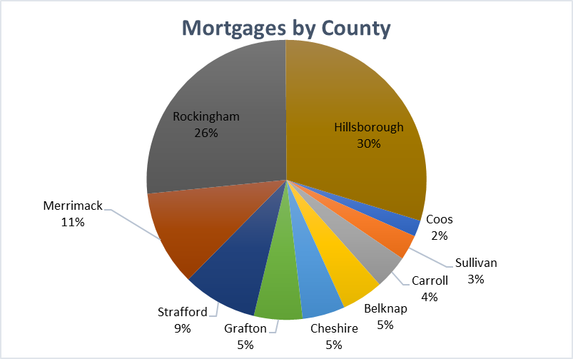

The real estate values and ownership costs also vary significantly by county. The graph below charts monthly owner costs provided by the U.S. Census Bureau, 2015-2019 American Community Survey
5-Year Estimates.

These estimates are the sum of payments for mortgages, deeds of trust, contracts to purchase, or similar debts on the property (including payments for the first mortgage, second mortgages, home equity loans, and other junior mortgages), real estate taxes, homeowner’s insurance, utilities (electricity, gas, water, and sewer), and fuels (oil, coal, kerosene, wood, etc.). It also includes, where appropriate, the monthly condominium fee for condominiums and manufactured housing costs (installment loan payments, real estate taxes, site rent, registration fees, and license fees).

Based on data provided by the Federal Housing Administration (FHA), Fannie Mae, Rural Development, and Federal Housing Finance Agency (FHFA) it is estimated that approximately 70% of mortgages in New Hampshire are federally backed. A “federally backed mortgage loan” is defined to include any loan secured by a first or subordinate lien on residential real property, including individual units of condominiums and cooperatives, designed principally for the occupancy of one- to four-families, that is:

- Insured by the FHA under Title II of the National Housing Act, which is the main title under which FHA insures residential mortgage loans; or
- Insured under National Housing Act section 255, which addresses home equity conversion (i.e., reverse) mortgage loans insured by FHA; or
- Guaranteed under the Housing and Community Development Act of 1992, sections 184 or 184A, which address loans related to Native American families and housing authorities and loans related to Native Hawaiian families and authorities; or
- Guaranteed or insured by the U.S. Department of Veterans Affairs (VA); or
- Guaranteed or insured by the U.S. Department of Agriculture (USDA); or
- Made by the USDA; or
- Purchased or securitized by Fannie Mae or Freddie Mac.

It is estimated that 30% of mortgages in the State fall within the category of “private label securities” and “portfolio mortgages.” These mortgages did not require servicers to provide for mortgage forbearance as part of the Coronavirus Aid, Relief, and Economic Security (CARES) Act.

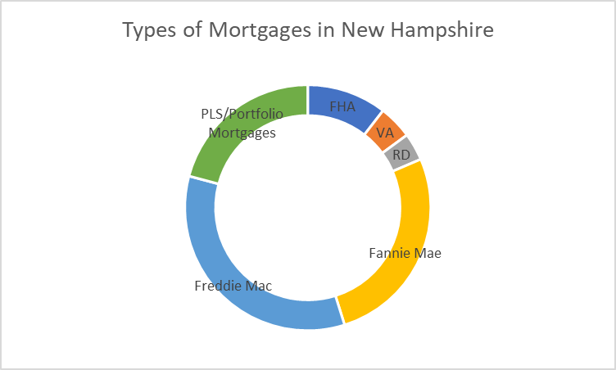

Demographics
New Hampshire has a relatively small non-White population: 92.6% of the state’s population is identified by race as White alone.

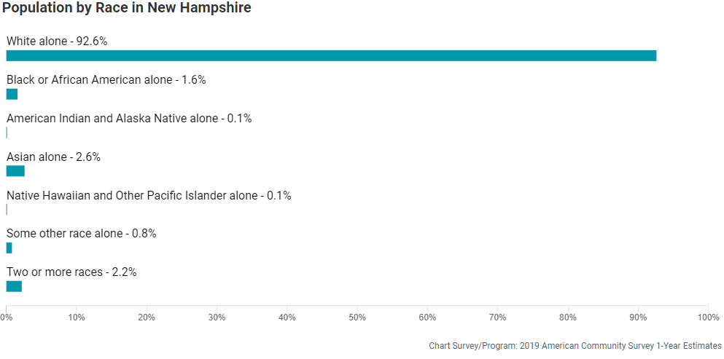

The White/non-Hispanic population represents 89% of the population. Approximately 95% of the homeowners in the state are White/non-Hispanic. It is estimated that at least 19,000 homeowners in the state fall within the definition of Socially Disadvantaged Individuals.²

2015-2019 American Community Survey Table B25003A; B25003B; B25003C; B25003D; B25003E; B25003F; B25003G; AND B25003I

Several communities have been identified based on Census information to have a higher concentration of Socially Disadvantaged Individuals² living there. Therefore, marketing efforts will be concentrated in those communities, as follows:

Nashua Berlin
Manchester Ossipee
Hanover Lebanon
West Lebanon Portsmouth
Somersworth Dover
Lee Greenland
Salem Concord
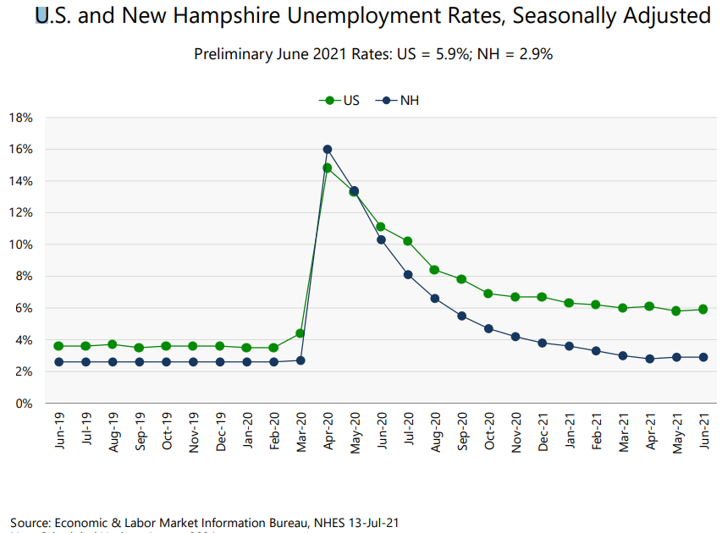
Unemployment Data
In June 2021, New Hampshire had the lowest unemployment rate in the country at 2.9% (national rate was 5.9%). While this shows that the state’s economy has improved from its pandemic related high unemployment rate, many borrowers have been unable to recover financially from the impact of the pandemic by way of their ability to work and earn a sufficient income to maintain their household.

While the unemployment rate is very low in the state, many businesses across New Hampshire suffer from a lack of employees and have had to alter business operations and hours accordingly. Jobs in New Hampshire are down according to the graph included in the University of New Hampshire Carsey School of Public Policy’s report on COVID-19 Economic Crisis: By State.³ Total jobs in June 2021 are estimated at 656,600, compared to pre-pandemic levels of 689,000.

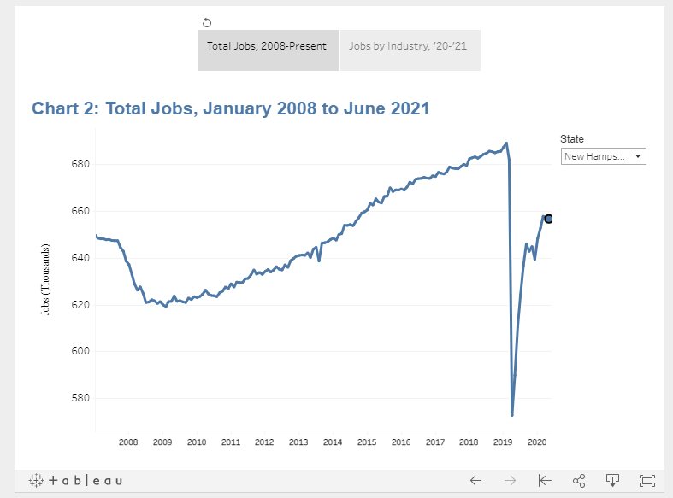

Delinquency/Foreclosure Activity
As of March 31, 2021, the Mortgage Bankers Association (MBA) Delinquency Report indicated that 4.74% of loans in New Hampshire are delinquent, with 3.28% being seriously delinquent (90 days or more). The December 31, 2019 report indicated a total delinquency of 3.80%, with 1.28% being seriously delinquent. Based on MBA data, FHA borrowers often have higher delinquency rates. In a similar comparison, 11.82% of the FHA loans as of March 31, 2021, are delinquent, with 8.90% being seriously delinquent and 8.14% and 2.57% respectively as of December 31, 2019.

New Hampshire Housing services a portfolio of approximately 8,300 loans and has experienced delinquency levels that exceed national trends. This trend is the result of income restrictions focusing on low- and moderate-income borrowers as well as New Hampshire Housing’s relatively higher proportion of FHA and down-payment assistance loans.

As of July 12, 2021, the MBA’s latest Forbearance and Call Volume Survey indicated that the total number of New Hampshire loans in forbearance is 3.87%, with the share of Fannie Mae and Freddie Mac loans in forbearance at 1.91%. The proportion of Ginnie Mae loans in forbearance is 4.78%, while the share for portfolio loans and private-label securities is 7.94%.

As of June 30, 2021, New Hampshire Housing has 5.17% of its portfolio in forbearance, 2.60% of Fannie Mae loans in forbearance and 7.34% of Ginnie Mae loans in forbearance. New Hampshire Housing has experienced 50% of borrowers voluntarily withdraw themselves from forbearance, 15% resolve their forbearance through a loan modification, deferment, or partial claim, and the remaining 35% are either in active forbearance or working through a resolution process.

Based on the information provided by MBA, 82.7% of New Hampshire forbearance borrowers have requested a forbearance extension and 6.5% of forbearance borrowers have re-entered forbearance. This data indicates that a significant number of borrowers still struggle to keep up with or reinstate their mortgages. New guidelines have extended the forbearance request deadline until September 30, 2021.

The Federal Housing Finance Agency (FHFA) extended the foreclosure moratorium for mortgages backed by Fannie Mae and Freddie Mac until July 31, 2021. A new Consumer Financial Protection Bureau (CFPB) rule effective August 31, 2021, restricts servicer initiation of foreclosures between September 1, 2021, and December 31, 2021, based on Consumer Financial Protection Bureau guidelines. As of March 31, 2021, the MBA estimated 0.02% of the loans in New Hampshire are in foreclosure, compared to 0.17% as of December 31, 2019.

Utility Data
Eversource Energy, Liberty Utilities, and the New Hampshire Electric Cooperative have provided data to the general public in response to a request for information from the New Hampshire Public Utilities Commission. Information was provided for residential users but not separated by owner-occupied units and rental units. All providers indicated that regular residential collections resumed, and payment plans, and assistance plans are being established with customers. Delinquency varied by provider and ranged from 20% to 40% of customers.

Public Participation and Community Engagement

New Hampshire Housing held six stakeholder meetings which included a total of 42 participants. These meetings included mortgage banking and real estate professionals, insurance and community association representatives, housing counselors & legal services, community organizations and non-profit groups that focus on socially disadvantaged populations, utility providers, and state and town municipalities. Staff interacted frequently with these diverse stakeholders to gather input while drafting the plan. Additionally, staff attended numerous national calls with other HAF state providers and with national servicers to ensure New Hampshire Housing considered best practices.

Since the HAF Guidance was originally published on April 14, 2021, New Hampshire Housing had discussions with several of the largest mortgage loan servicers of government loans in New Hampshire. Principal discussions pertain to homeowners with delinquent loans and loans in forbearance, and the processes by which these loans can be reinstated using HAF monies. New Hampshire Housing has reached out to the master servicer and others for data relating to the number of loans that are past due and the amount required to reinstate. New Hampshire Housing has met with the New Hampshire Mortgage Bankers & Brokers Association to discuss their memberships’ needs for homeowners with delinquent loans and loans in forbearance. In addition, New Hampshire Housing staff are participating in calls with the Housing Policy Council, which includes many of the largest servicers in the country as well as in New Hampshire, to discuss ways to assist homeowners by developing effective HAF programs that can be implemented nationally.

We will continue to actively engage and seek community and public participation. New Hampshire Housing will leverage existing partnerships with mortgage servicers, lenders, Realtors, housing counseling organizations, community development corporations, and local offices as community navigators with an emphasis on low income, minority, and socially disadvantaged populations.

New Hampshire Housing published its draft HAF Plan for public comment on August 31, 2021, with a public comment period through September 13, 2021. New Hampshire Housing conducted a public hearing on the draft HAF Plan on September 8, 2021. This public hearing was attended by 41 individuals, representing 25 organizations, and 8 of the 10 different counties in New Hampshire. Of the organizations present, 44% primarily serve low to moderate income households and 60% directly address the impacts of housing discrimination.

Program Design

New Hampshire Housing is presenting its initial HAF Plan to US Treasury with three programs:
- The Mortgage Loan Reinstatement Program (Reinstatement HAF)
- Property Charges Default Resolution Program (Property Charges HAF); and
- Utility/Internet/Payment Assistance Program (Utility HAF).

The state reserves the right to submit additional programs to US Treasury for consideration based on homeowner needs and/or program results. New Hampshire Housing will be reassessing the need for additional programs or changes in current programs continually from the launch. Specifically, New Hampshire Housing will conduct a review every three months. At that time, New Hampshire Housing will determine whether any changes need to be made to eligibility requirements, the document submission process, and/or program maximums, or if there is a need to establish additional programs. New Hampshire Housing is committed to helping resolve defaults that threaten a homeowner’s ability to sustain ownership of the property.

For all HAF Programs:

- The overall household maximum amount of HAF funds per household will be $20,000.
- Consistent with US Treasury guidance, all eligible applicants will be required to seek loss mitigation options with their servicer prior to receiving HAF funds; however, an exception clause is in place for those:
  - Whose servicer has not been timely and responsive with a homeowner’s loss-mitigation efforts;
  - Who have demonstrated imminent threat of losing their home, which makes it unlikely that loss mitigation can be completed in time; or
  - Who for other good cause when other extenuating circumstances outside of the homeowner’s control prevent completion of loss mitigation.

New Hampshire Mortgage Loan Reinstatement Program (Reinstatement HAF)
The goal of this program is to eliminate or reduce mortgage loan delinquencies associated with the pandemic and prevent foreclosures and homeowner displacement by reinstating mortgage loans. This program is modeled after the well-known Hardest Hit Fund program. Because of this, New Hampshire Housing expects to assist many delinquent and at-risk homeowners in a quick and efficient manner using a process known to mortgage loan servicers. Through this program and process, delinquent mortgage loans will be reinstated, fully or partially, allowing homeowners to remain in their homes and avoid foreclosure and displacement. Homeowners will also be required to seek loss mitigation programs available through their lender/servicer prior to receiving HAF assistance. In addition, any applicant not able to show the ability to make future mortgage payments will be referred for pre-foreclosure counseling with a HUD-certified counseling agency.

The Reinstatement HAF program maximum will be $20,000 and subject to overall household maximum HAF benefit amount of $20,000.

If the cumulative total amount of assistance for any or all programs exceeds $5,000, then the assistance will be restructured as a two-year forgivable grant. The grant will be due in full upon sale, cash-out refinance, or transfer of ownership. If no resale, refinance, or transfer of ownership occurs within two years the grant will be fully forgiven. If the amount of assistance is less than $5,000, then assistance will be in the form of a non-recourse grant.

New Hampshire Housing will allocate up to $28,600,000 of its HAF allocation for the Reinstatement HAF program. This allocation is subject to change if New Hampshire Housing develops any additional HAF programs.

New Hampshire Property Charges Default Resolution Program (Property Charges HAF)
The goal of this program is to eliminate delinquent property taxes, insurance premiums, homeowners’ association (HOA) fees, condominium fees, cooperative maintenance, manufactured housing lot rent and common charges (property charges). Through this program and process, delinquent property charges will be reinstated, fully or partially, allowing homeowners to remain in their homes and avoid tax deed and displacement. Reasonable late fees, interest, and legal fees may be considered in the amount of arrearage if the party owed these fees has first attempted to exhaust all options to waive or reduce them.

The Property Charges HAF program maximum will be $20,000 and subject to overall household maximum HAF benefit amount of $20,000.

If the cumulative total amount of assistance for any or all programs exceeds $5,000, then the assistance will be restructured as a two-year forgivable grant. The grant will be due in full upon sale, cash-out refinance, or transfer of ownership. If the amount of assistance is less than $5,000, then assistance will be in the form of a non-recourse grant. If no resale, refinance, or transfer of ownership occurs within two years the grant will be fully forgiven.

New Hampshire Housing will allocate up to $8,400,000 of its HAF allocation for the Property Charges HAF Program. This allocation is subject to change if New Hampshire Housing develops any additional HAF programs.

New Hampshire Utility/Internet Payment Assistance Program (Utility HAF)
The goal of this program is to pay delinquent utility (including electric, gas, home energy and home internet) amounts in full, including interest or reasonably required legal fees, under circumstances in which a delinquency threatens access to utility services. Applicants applying for assistance to pay internet delinquency will receive a flat rate of up to $50.00 per each month of delinquency, not to exceed the $3,000 limit. Reasonable late fees, interest, and legal fees may be considered in the amount of arrearage if the party owed these fees has first attempted to exhaust all options to waive or reduce them.

Subject to a program maximum of $3,000 and subject to overall household maximum HAF benefit amount of $20,000.

If the amount of assistance is less than $5,000, then assistance will be in the form of a non-recourse grant. If the cumulative total amount of assistance for any or all programs exceeds $5,000, then the assistance will be restructured as a two-year forgivable grant. The grant will be due in full upon sale, cash-out refinance, or transfer of ownership. If no resale, refinance, or transfer of ownership occurs within two years the grant will be fully forgiven.

New Hampshire Housing will allocate up to $3,000,000 of its HAF allocation to the Utility HAF program. This allocation is subject to change if New Hampshire Housing develops any additional HAF programs.
Intake Process for All Programs

The application and intake process will be designed and operated in a manner to avoid barriers to equitable access and allow for maximum flexibility. Homeowners will be able to apply through a mobile-friendly online portal that will allow for the upload of all supporting documents. The application portal and related information about the application process will be made available in multiple languages. Homeowners who cannot access the online portal may apply for assistance by phone or in person through a contracted company.

Housing Counseling
The state plans to allocate no more than 2.5% (or $1,250,000) of HAF funds to provide free in-state housing counseling services to at-risk homeowners. Housing Counseling service providers will also be required to provide community navigator services to help eligible applicants apply for HAF funds. All applicants will be eligible to receive these services and New Hampshire Housing will strongly encourage their participation.

Applicants receiving funding under the Mortgage Loan Reinstatement Program who are not able to afford the monthly payment going forward will be directly referred to attend pre-foreclosure housing counseling. Housing counseling will be made available to all applicants who apply for HAF programs, are ineligible for HAF programs, and/or have been denied a loss mitigation solution through the lender/servicers.

Legal Aid
The state plans to allocate no more than 2.5% (or $1,250,000) of HAF funds to provide free in-state legal services to at-risk eligible homeowners. Legal service providers will also be required to provide Community Navigator services to help eligible applicants apply for HAF funds. All applicants will be entitled to receive these services.

Administration Allocation

In all cases, HAF monies budgeted and approved for administrative expenses will not exceed 15%. In addition, any unused administrative funds will be reallocated to provide additional homeowner assistance.

Targeting HAF Funding

In accordance with US Treasury’s HAF Guidance, applicants will be prioritized in the following manner:

- Homeowners who make 50% or less of the area median income. New Hampshire Housing recognizes that homeowners at this income level are often in portfolios of government-backed and guaranteed mortgages and may be in most need.
- Homeowners who can demonstrate that they were granted refugee or asylum status by the U.S. government pursuant to the Immigration and Nationality Act. These homeowners may also be eligible for higher prioritization as Socially Disadvantaged Individuals⁽³⁾ due to limited English proficiency.
- Homeowners having 100% or less of the area median income. New Hampshire Housing recognizes that homeowners at this income level are often in portfolios of government-backed and guaranteed mortgages. As such, New Hampshire Housing will prioritize assistance to homeowners with FHA, VA, and USDA mortgages along with homeowners who have obtained mortgages with proceeds of mortgage revenue bonds.
- Socially Disadvantaged Individuals as defined in the HAF Guidance dated August 2, 2021, are those whose ability to purchase or own a home has been impaired due to diminished access to credit on reasonable terms as compared to others in comparable economic circumstances, based on disparities in homeownership rates in the HAF participant’s jurisdiction as documented by the U.S. Census. The impairment must stem from circumstances beyond their control. Indicators of impairment under this definition may include being a (1) member of a group that has been subjected to racial or ethnic prejudice or cultural bias within American society; (2) resident of a majority-minority Census tract; or (3) individual with limited English proficiency.
New Hampshire Housing may, at a later date, determine other groups in New Hampshire to be socially disadvantaged individuals and in accordance with US Treasury guidance will, at that time, develop a process for determining those groups as socially disadvantaged individuals in accordance with applicable law, which may reasonably rely on self-attestations.
- Non-Traditional Loans and Properties. Recognizing the unique needs of homeowners in rural communities with less housing stock than larger Metropolitan Statistical Areas (MSA), New Hampshire Housing will prioritize homeowners who would not typically be included in Government Loan and Affordable Housing Portfolios. New Hampshire Housing will be able to assist homeowners with less traditional financing instruments, including a contract for deed and reverse mortgages, and will be able to provide assistance to homeowners whose property is a manufactured home as defined by New Hampshire RSA 205-A. Homeowners of manufactured housing may not be able to qualify for traditional loan products containing competitive market rates and may have mortgages with higher rates and shorter terms.
- Government Loan and Affordable Housing Portfolios. New Hampshire Housing will prioritize assistance to eligible homeowners with FHA, VA, and USDA mortgages and homeowners who have mortgages made with the proceeds of mortgage revenue bonds or other mortgage programs that target low- and moderate-income homeowners.
- Eligible Homeowners with incomes between 100% and 125% of the area median income or with incomes equal to or less than 100% of the median income for the United States, whichever is greater.
Outreach and Marketing Plan

New Hampshire’s HAF outreach and marketing plan will include a designated webpage on the New Hampshire Housing website and a unique website that will prominently display HAF program information, as well as offer guidance and resources to individuals experiencing homeownership or rental housing instability. New Hampshire Housing will actively and regularly engage in HAF and related topics on social media, in news releases, and digital and print advertising, as well as other messaging channels such as PSAs and community outreach. In addition, New Hampshire Housing will leverage existing partnerships with mortgage servicers, lenders, Realtors, housing counseling organizations, community development corporations, and local offices as community navigators with an emphasis on low income, minority, and socially disadvantaged populations. Outreach and marketing materials will be made available in multiple languages.

New Hampshire Housing will, on a quarterly basis, review its outreach and marketing efforts, in conjunction with its performance goals, to assess and re-strategize its communications, outreach and marketing efforts to targeted homeowners.

Best Practices and Coordination with Other HAF Participants

New Hampshire Housing’s Homeownership Division staff regularly interacts with housing counseling organizations, community development corporations, mortgage lenders, and servicers throughout the state, with topics of discussion ranging from delinquencies and forbearances to the lack of affordable housing in the state.

Since the HAF Guidance was originally published on April 14, 2021, New Hampshire Housing has participated in regular discussions with other HAF participants via virtual meetings/calls coordinated by the National Council of State Housing Agencies (NCSHA). Additionally, on-going discussions continue with several of the largest servicers of government loans in New Hampshire regarding delinquent loans and loans in forbearance and the process by which those loans can be reinstated, statewide affordable housing programs on delinquency and forbearance information from their master servicers, and the New Hampshire Bankers Association to identify mortgage loan delinquencies throughout the state. Also, New Hampshire Housing staff participate in calls with the Housing Policy Council, which includes many of the largest servicers in the country as well as in New Hampshire, to discuss ways to effectively assist homeowners as efficiently as possible.

New Hampshire Housing will continue to actively engage with all housing partners to establish and implement best practices for HAF for the life of the program.

Performance Goals

New Hampshire Housing will measure performance by evaluating the following:

- The speed by which an applicant receives a final determination of benefit assistance, from initial inquiry to disbursement of funds, denial, or withdrawal of application. The State of NH will assure the time from full application submission to disbursement, denial, or withdrawal is no longer than 45 days.
- The number of households served and the amount of financial HAF program assistance provided.
- The number and percentage of applicants who received assistance through the program (versus the number and percentage of denied and/or withdrawn applications).
- The number of households served and the dollar amount of HAF assistance provided to homeowners, expressed in area median income ranges and number of persons in the household.
- Effectiveness in broad outreach and providing assistance to SDI communities and homeowners. This will be judged on demographic data of homeowners in SDI communities as compared to HAF homeowners served. (State of NH will compare New Hampshire’s SDI data, determine the percentage of SDI homeowners in New Hampshire and compare those numbers with HAF homeowners served).

- Housing counseling and legal services are an essential part of State of NH approach to the HAF Program and therefore an additional measure of success will be how many homeowners were assisted or represented by either obtaining favorable results or helpful advice in a time of great emotional, familial, and financial stress.

Readiness

Staffing and Systems
Requests for proposals were issued, and responses were received for staffing, systems, and services required, including call center operations, application intake, review and processing, reporting, resource data, hardware and software, external IT/IS support, communications and marketing, program audit and compliance, quality control reviews and recommendations, and disbursement of funds. New Hampshire Housing will evaluate the submissions and select the vendor, or combination of vendors, that will result in the most efficient and effective operations and support for the overall administration of New Hampshire’s HAF program.

New Hampshire Housing’s vendor contract was signed on November 19, 2021 and will soon begin to test the systems and review processes, develop detailed program guides, policies and procedures, and address changes necessary to accommodate feedback from US Treasury regarding the HAF Plan. The application website is slated to open by February 1, 2022.

Contracts and Partnerships
In addition to the contracts resulting from requests for proposals described above, New Hampshire Housing will partner with mortgage loan servicers through the mutual execution of a Servicer Partner Agreement. New Hampshire Housing will work closely with qualified housing counselors, community development corporations, community development financial institutions, and other non-profit organizations with the capacity to assist homeowners applying to HAF programs. In particular, staff have sought out entities that can assist with reaching low- to moderate-income homeowners with less traditional mortgage loans and expect to contract with these providers on a pay-for-performance basis.

Existing and Pilot Programs
New Hampshire Housing currently administers the New Hampshire Emergency Rental Assistance Program. New Hampshire Housing plans to use similar processes and operational procedures, modified as necessary to adapt to the specific needs and requirements of HAF.

Budget

New Hampshire HAF Allocation |  |  |  |  | $ 50,000,000.00
 | Administration Expenses (up to 15%) |  |  |  | $ 7,500,000.00
 | Housing Counseling Services (up to 2.5%) |  |  |  | $ 1,250,000.00
 | Legal Aid Services (up to 2.5%) |  |  |  | $ 1,250,000.00
 |  | Balance Available for Programs |  |  | $ 40,000,000.00
 | Mortgage Loan Reinstatement Program |  |  |  | $ 28,600,000.00
 | Property Charges Default Resolution Program |  |  |  | $ 8,400,000.00
 | Utility/Internet/Payment Assistance Program |  |  |  | $ 3,000,000.00

Footnotes

- Census Data
- Socially Disadvantaged Individuals, as defined in the HAF Guidance dated August 2, 2021, as those whose ability to purchase or own a home has been impaired due to diminished access to credit on reasonable terms as compared to others in comparable economic circumstances, based on disparities in homeownership rates in the HAF participant’s jurisdiction as documented by the U.S. Census. The impairment must stem from circumstances beyond their control. Indicators of impairment under this definition may include being a (1) member of a group that has been subjected to racial or ethnic prejudice or cultural bias within American society, (2) resident of a majority-minority Census tract; (3) individual; with limited English proficiency; (4) resident of a U.S. territory, Indian reservation, or Hawaiian Home Land, or (5) individual who lives in a persistent-poverty county, meaning any county that has had 20% or more of its population living in poverty over the past 30 years as measured by the three most recent decennial censuses. In addition, an individual may be determined to be a socially disadvantaged individual in accordance with a process developed by a HAF participant for determining whether a homeowner is a socially disadvantaged individual in accordance with applicable law, which may reasonably rely on self-attestations.
- https://carsey.unh.edu/COVID-19-Economic-Impact-By-State
- https://www.puc.nh.gov/Regulatory/Docketbk/2020/20-089/LETTERS-MEMOS-TARIFFS/20-089_2021-06-30_LIBERTY_UTILITIES_RESPONSES_OON_REQUESTS.PDF
- https://www.puc.nh.gov/Regulatory/Docketbk/2020/20-089/LETTERS-MEMOS-TARIFFS/20-089_2021-06-30_EVERSOURCE_RESPONSES_OON_REQUESTS.PDF
- https://www.puc.nh.gov/Regulatory/Docketbk/2020/20-089/LETTERS-MEMOS-TARIFFS/20-089_2021-06-30_NHEC_RESPONSES_OON_REQUESTS.PDF

New Hampshire Housing Finance Authority
Mortgage Loan Reinstatement Program (Reinstatement HAF)

Program Overview | The Homeowner Assistance Fund (HAF) program was established under Section 3206 of the American Rescue Plan Act of 2021 (ARP) to mitigate financial hardships associated with the coronavirus pandemic by providing funds to eligible entities for the purpose of preventing homeowner mortgage delinquencies, defaults, foreclosures, loss of utilities or home energy services, and displacement of homeowners experiencing financial hardship after January 21, 2020 or began prior to but continued after January 21, 2020 through payment of qualified expenses related to mortgages and housing.  Note:  - The overall household maximum amount of HAF funds per household will be $20,000.  - Consistent with US Treasury guidance, all Eligible Homeowners will be required to seek loss mitigation options with their servicer prior to receiving HAF funds; however, an exception clause is in place for those:  - Whose servicer has not been timely and responsive with a homeowner’s loss-mitigation efforts;  - Who have demonstrated imminent threat of losing their home, which makes it unlikely that loss mitigation can be completed in time; or  - Who for other good cause when other extenuating circumstances outside of the homeowner’s control prevent completion of loss mitigation.
Brief Description | The program will provide financial assistance to eliminate or reduce past due payments and other delinquent amounts, including payments under a forbearance plan and payments on forward mortgages, reverse mortgages, loans secured by manufactured homes.  HAF funds may be used to bring accounts partially or fully current and to repay amounts advanced by the lender or servicer on the borrower’s behalf for property charges, including taxes, hazard insurance premiums, flood or wind insurance premiums, ground rents, condominium fees, cooperative maintenance fees, planned unit development fees, homeowners’ association fees, or utilities that the servicer advanced to protect a lien position. Payments may also include reasonably required legal fees.  Any applicant not able to show the ability to make future payments will be referred for pre-foreclosure counseling with a HUD-certified counseling agency.  HAF Funds will be used only to supplement other loss mitigation options offered by the servicer under investor requirements or where, without HAF funds, the homeowner would not qualify for a loss mitigation option.  New Hampshire Housing will undertake a best effort approach to leverage the assistance that might be available for eligible homeowners through other programs.
Maximum Amount of Assistance per Homeowner | Each homeowner will be eligible for up to $20,000 through this program with respect to the applicant’s primary residence.  New Hampshire Housing HAF funds will not exceed the Maximum Per Household HAF Assistance amount of $20,000. New Hampshire Housing will allocate up to $28,600,000 of its total HAF funding for this program. This amount excludes administrative expenses.
Eligible Homeowners | Eligible Homeowners must meet the following criteria:  - Must have experienced a Qualified Financial Hardship after January 21, 2020 or began prior to but continued after January 21, 2020 and provide an attestation describing the nature of the financial hardship;  - Must currently own and occupy the property as their primary residence;  - In circumstances where a tax deed has occurred, must have an equitable, statutory, or other right to reclaim legal ownership and must be currently still occupying the property as their primary residence;  - Must meet the Homeowner Income Eligibility Requirements;  - The original principal balance of the homeowner’s first mortgage or housing loan, at the time of origination, is not greater than the conforming loan limit;  - Must attest to have not received any Federal assistance or mortgage relief under the Homeowner Assistance Fund or the New Hampshire Emergency Rental Assistance program;  - Ownership structure: must be owned by a “natural person or persons” (e.g., LLP, LP, or LLC do not qualify); and  - Those where the homeowner has transferred their ownership right into non-incorporated, living trusts, provided the homeowner occupies the home as the primary/principal residence.  Co-owners are not permitted to separately apply for HAF Program assistance.
Qualified Financial Hardship | A Qualified Financial Hardship is a material reduction in income or material increase in living expenses associated with the coronavirus pandemic that has created or increased a risk of mortgage delinquency, mortgage default, foreclosure, loss of utilities or home energy services, or displacement for a homeowner.  - Reduction of Income - Documented temporary or permanent loss of earned income that occurred after January 21, 2020 or began prior to but continued after January 21, 2020; or  - Increase in living expenses - Documented increase in out-of-pocket household expenses such as medical expenses, inadequate medical insurance, increase in household size, or costs to reconnect utility services directly related to the coronavirus pandemic that occurred after January 21, 2020 or began prior to but continued after January 21, 2020.
Homeowner Income Eligibility Requirements | To be eligible for assistance, borrower/co-borrower must document that at the time of hardship:  - Income(s) equal to or less than 125% of the area median income (2.5 times the income limit for very low-income families, for the relevant household size) or  - Income(s) equal to or less than 100% of the median income for the United States, whichever is greater, unless US Treasury requires a lower amount per household size.  - New Hampshire Housing reserves the ability to revise the document requirements for borrower eligibility to ensure a proper balance between helping homeowners while ensuring adequate eligibility safeguards are in place.
Eligible Properties | Eligible Properties are those that are owner-occupied, or in the case of a land contract or contract for deed, occupied by the documented buyer, and include:  - Single-family (attached or detached) properties;  - Condominium units;  - 1- to 4-unit properties where the homeowner is living in one of the units as their primary residence;  - Manufactured/modular homes permanently affixed to real property and taxed as real estate; and  - Manufactured homes not permanently affixed to real property but with a Title Certificate or Statement of Ownership in the homeowner’s name.  Ineligible properties:  - Vacant or abandoned properties;  - Second homes;  - Investment properties.
Documentation  Requirements | The following documents (if applicable) will be required for an application to be considered complete:  - Application;  - Third Party Authorization (TPA) and Disclosure Form;  - Grant Agreement Disclosure;  - Qualifying hardship attestation and supporting documentation from homeowner certifying and identifying the eligible hardship and that occurred after January 21, 2020 or began prior to but continued after January 21, 2020;  - Mortgage statement for each lien (e.g., first mortgage, second mortgage, reverse mortgage);  - Proof of completed loss mitigation;  - Manufactured home loan statement;  - Manufactured home loan statement and/or lot rental agreement (homeowners that received assistance through the New Hampshire Rent Relief Program are ineligible to receive assistance through this Program);  - A copy of original mortgage;  - Land Contract agreement, if applicable;  - Deed;  - Current property tax bill;  - Social Security Number card or unique identifier as shown on a legal document, such as federal tax return;  - Income documentation (Including, but not limited to: W2’s, paystubs, previous years’ tax returns or alternative income documents as applicable).  - Exception: Written self-attestation will be permitted as the basis for determining income in circumstances where documentation is not available due to extenuating circumstances including, but not limited to, disabilities, lack of technological access, or lost or unavailable records. Written attestation will be accepted from the applicant, housing counselor, attorney, or other professional with knowledge of the applicant’s circumstances.  - New Hampshire Housing reserves the ability to revise the document requirements for borrower eligibility to ensure a proper balance between helping homeowners while ensuring adequate eligibility safeguards are in place
Form of Assistance | Assistance will be structured as a two-year, non-interest bearing, non-amortizing forgivable grant. The grant is due in full upon sale, cash-out refinance, or transfer of ownership. If no resale, transfer, or refinance occurs within two years and the borrower remains in the home, the grant will be fully forgiven.  If the cumulative total amount of assistance for any or all programs is less than $5,000 it will be in the form of a non-recourse grant.
Payment Requirements | New Hampshire Housing will disburse HAF assistance directly to the mortgage lender/servicer, land contract or contract for deed holder, manufactured home lender manufactured home park (whether owned individually or collectively, as in a Resident Owned Community (ROC)). Funds will not be disbursed to Eligible Homeowners, or any other non-eligible entity.  Payments to lenders/servicers are only permissible to the extent the lender/servicer holds an NMLS number or is federally exempt from holding one.  Eligible Homeowners may be eligible for additional HAF assistance through other HAF Programs that may be implemented in the future, subject to the Maximum Per Household HAF Assistance.  New Hampshire Housing will disburse assistance amounts quoted by the eligible entity. Any discrepancies in the amount disbursed are to be resolved by the homeowner and eligible entity.  Lender/servicers must execute a HAF Collaboration Agreement and agree to communicate using the Common Data File (CDF) format.  Private non-mortgage lenders, including land contract, contract for deed, and manufactured home lenders/lot rent payees are to provide a written delinquency quote, contact information, and ACH account information.  If Eligible Homeowner’s delinquent amount exceeds the Per Item Maximum Amount or Maximum Per Household HAF Assistance, New Hampshire Housing will pay the maximum permissible amount and the homeowner may pay the difference, if allowed by the Eligible Entity.

New Hampshire Housing Finance Authority
Property Charges Default Resolution Program (Property Charges HAF)

Program Overview | The Homeowner Assistance Fund (HAF) program was established under Section 3206 of the American Rescue Plan Act of 2021 (ARP) to mitigate financial hardships associated with the coronavirus pandemic by providing funds to eligible entities for the purpose of preventing homeowner mortgage delinquencies, defaults, foreclosures, loss of utilities or home energy services, and displacement of homeowners experiencing financial hardship after January 21, 2020 or began prior to but continued after January 21, 2020 through payment of qualified expenses related to mortgages and housing.  Note:  - The overall household maximum amount of HAF funds per household will be $20,000.  - Consistent with US Treasury guidance, all Eligible Homeowners will be required to seek loss mitigation options with their servicer prior to receiving HAF funds; however, an exception clause is in place for those:  - Whose servicer has not been timely and responsive with a homeowner’s loss-mitigation efforts;  - Who have demonstrated imminent threat of losing their home, which makes it unlikely that loss mitigation can be completed in time; or  - Who for other good cause when other extenuating circumstances outside of the homeowner’s control prevent completion of loss mitigation.
Brief Description | The program will provide financial assistance to resolve any property charge default that threatens a homeowner’s ability to sustain ownership of the property, whether concurrently with other loss mitigation options offered by the loan servicer or in conjunction with other assistance programs.  HAF Funds may be used to pay past due property taxes, property insurance premiums, homeowners association (HOA) fees, condominium fees, cooperative maintenance, manufactured home lot rents or common charges that threaten sustained ownership of the property must be brought current by program assistance or resolved concurrently with assistance provided by the program. Reasonable late fees, interest, and legal fees may be considered in the amount of arrearage if the party owed these fees has first attempted to exhaust all options to waive or reduce them.  New Hampshire Housing will undertake a best effort approach to leverage the assistance that might be available for Eligible Homeowners through other programs.
Maximum Amount of Assistance per Homeowner | Each homeowner will be eligible for up to $20,000 through this program with respect to the applicant’s primary residence.  New Hampshire Housing HAF funds will not exceed the Maximum Per Household HAF Assistance amount of $20,000.  New Hampshire Housing will allocate up to $8,400,000 of its total HAF funding for this program. This amount excludes administrative expenses.
Eligible Homeowners | Eligible Homeowners must meet the following criteria:  - Must have experienced a Qualified Financial Hardship after January 21, 2020 or began prior to but continued after January 21, 2020 and provide an attestation describing the nature of the financial hardship;  - Must currently own and occupy the property as their primary residence;  - In circumstances where a tax deed has occurred, must have an equitable, statutory, or other right to reclaim legal ownership and must be currently still occupying the property as their primary residence;  - Must meet the Homeowner Income Eligibility Requirements;  - The original principal balance of the homeowner’s first mortgage or housing loan, at the time of origination, is not greater than the conforming loan limit;  - Must attest to have not received any Federal assistance or mortgage relief under the Homeowner Assistance Fund or the New Hampshire Emergency Rental Assistance program;  - Ownership structure: must be owned by a “natural person or persons” (e.g., LLP, LP, or LLC do not qualify); and  - Those where the homeowner has transferred their ownership right into non-incorporated, living trusts, provided the homeowner occupies the home as the primary/principal residence.  Co-owners are not permitted to separately apply for HAF Program assistance.
Qualified Financial Hardship | A “Qualified Financial Hardship” is a material reduction in income or material increase in living expenses associated with the coronavirus pandemic that has created or increased a risk of mortgage delinquency, mortgage default, foreclosure, loss of utilities or home energy services, or displacement for a homeowner.  - Reduction of Income - Documented temporary or permanent loss of earned income that occurred after January 21, 2020 or began prior to but continued after January 21, 2020; or  - Increase in living expenses - Documented increase in out-of-pocket household expenses such as medical expenses, inadequate medical insurance, increase in household size, or costs to reconnect utility services directly related to the coronavirus pandemic that occurred after January 21, 2020 or began prior to but continued after January 21, 2020 .
Homeowner Income Eligibility Requirements | To be eligible for assistance under Property Charges HAF, borrower/co-borrower must document that at the time of hardship:  - Income(s) equal to or less than 125% of the area median income (2.5 times the income limit for very low-income families, for the relevant household size) or  - Income(s) equal to or less than 100% of the median income for the United States, whichever is greater, unless US Treasury requires a lower amount per household size.  - New Hampshire Housing reserves the ability to revise the document requirements for borrower eligibility to ensure a proper balance between helping homeowners while ensuring adequate eligibility safeguards are in place.
Eligible Properties | Eligible Properties are those that are owner-occupied, or in the case of a land contract or contract for deed, occupied by the documented buyer, and include:  - Single-family (attached or detached) properties;  - Condominium units;  - 1- to 4-unit properties, where the homeowner is living in one of the units as their primary residence;  - Manufactured/modular homes permanently affixed to real property and taxed as real estate; and  - Manufactured homes not permanently affixed to real property but with a Title Certificate or Statement of Ownership in the homeowner’s name.  Ineligible properties:  - Vacant or abandoned properties;  - Second homes;  - Investment properties.
Documentation  Requirements | The following documents (if applicable) will be required for an application to be considered complete:  - Application;  - Third Party Authorization (TPA) and Disclosure Form;  - Grant Agreement Disclosure;  - Qualifying hardship attestation and supporting documentation from homeowner certifying and identifying the eligible hardship and that occurred after January 21, 2020 or began prior to but continued after January 21, 2020;  - Mortgage statement for each lien (e.g., first mortgage, second mortgage, reverse mortgage);  - Manufactured home loan statement;  - Manufactured home loan statement and/or lot rental agreement (homeowners that received assistance through the New Hampshire Emergency Rental Assistance Program are ineligible to receive assistance through this Program);  - Most recent property tax bill;  - Most recent insurance premium;  - Most recent association dues invoice;  - Most recent lot rent bill;  - Social Security Number card or unique identifier as shown on a legal document, such as federal tax return;  - Income documentation. Including but not limited to: W2’s, paystubs, previous years’ tax returns or alternative income documents as applicable.  - Exception: Written self-attestation will be permitted as the basis for determining income in circumstances where documentation is not available due to extenuating circumstances including, but not limited to, disabilities, lack of technological access, or lost or unavailable records. Written attestation will be accepted from the applicant, housing counselor, attorney, or other professional with knowledge of the applicant’s circumstances.  - New Hampshire Housing reserves the ability to revise the document requirements for borrower eligibility to ensure a proper balance between helping homeowners while ensuring adequate eligibility safeguards are in place
Form of Assistance | Assistance will be structured as a non-recourse grant.  If the cumulative total amount of assistance for any or all programs exceeds $5,000, then the assistance will be restructured as a two-year forgivable grant. The grant will be due in full upon sale, cash-out refinance, or transfer of ownership. If no resale, refinance, or transfer of ownership occurs within two years the grant will be fully forgiven.
Payment Requirements | New Hampshire Housing will disburse HAF assistance directly to property tax offices, insurance companies, homeowner associations, and condo associations. Funds will not be disbursed to Eligible Homeowners, or any other non-eligible entity.  Eligible Homeowners may be eligible for additional HAF assistance through other HAF Programs that may be implemented in the future, subject to the Maximum Per Household HAF Assistance.  New Hampshire Housing will disburse assistance amounts quoted by the Eligible Entity; any discrepancies in the amount disbursed are to be resolved by the homeowner and Eligible Entity.  Eligible Entities are to provide a written delinquency quote, contact information, and ACH account information.  If Eligible Homeowner’s delinquent amount exceeds the Per Item Maximum Amount or Maximum Per Household HAF Assistance, New Hampshire Housing will pay the maximum permissible amount and the homeowner may pay the difference, if allowed by the Eligible Entity.

New Hampshire Housing Finance Authority
Utility/Internet/Payment Assistance Program (Utility HAF)

Program Overview | The Homeowner Assistance Fund (HAF) program was established under Section 3206 of the American Rescue Plan Act of 2021 (ARP) to mitigate financial hardships associated with the coronavirus pandemic by providing funds to eligible entities for the purpose of preventing homeowner mortgage delinquencies, defaults, foreclosures, loss of utilities or home energy services, and displacement of homeowners experiencing financial hardship after January 21, 2020 or began prior to but continued after January 21, 2020 through payment of qualified expenses related to mortgages and housing.  Note:  - The overall household maximum amount of HAF funds per household will be $20,000.  - Consistent with US Treasury guidance, all Eligible Homeowners will be required to seek loss mitigation options with their servicer prior to receiving HAF funds; however, an exception clause is in place for those:  - Whose servicer has not been timely and responsive with a homeowner’s loss-mitigation efforts;  - Who have demonstrated imminent threat of losing their home, which makes it unlikely that loss mitigation can be completed in time; or  - Who for other good cause when other extenuating circumstances outside of the homeowner’s control prevent completion of loss mitigation.
Brief Description | The program will provide financial assistance to resolve delinquent payments for utility (including electric, gas and home energy, water and sewer) and/or internet access services.  HAF funds may be used to pay delinquent utility amounts in full, including interest or reasonably required legal fees, under circumstances in which a delinquency threatens access to utility services. Applicants applying for assistance to pay internet delinquency will receive flat rate of up to $50.00 per each month of delinquency, not to exceed $3,000. Reasonable late fees, interest, and legal fees may be considered in the amount of arrearage if the party owed these fees has first attempted to exhaust all options to waive or reduce them.
Maximum Amount of Assistance per Homeowner | Each Homeowner will be eligible for up to $3,000 through this program with respect to the applicant’s primary residence.  New Hampshire Housing HAF funds will not exceed the Maximum Per Household HAF Assistance amount of $20,000.  New Hampshire Housing will allocate up to $3,000,000 of its total HAF funding for this program. This amount excludes administrative expenses.
Eligible Homeowners | Eligible Homeowners must meet the following criteria:  - Must have experienced a Qualified Financial Hardship after January 21, 2020 or began prior to but continued after January 21, 2020 and provide an attestation describing the nature of the financial hardship;  - Must currently own and occupy the property as their primary residence;  - In circumstances where a tax deed has occurred, must have an equitable, statutory, or other right to reclaim legal ownership and must be currently still occupying the property as their primary residence;  - Must meet the Homeowner Income Eligibility Requirements;  - Must be at least one installment payment in arrears on one or more of the following:  - Utilities (electric, gas, home energy, water and sewer);  - Internet service (including broadband)  - HOA fees, condominium fees, cooperative maintenance, and common charges  - Assistance sufficient to resolve delinquency is not available from other utility assistance programs and, without HAF assistance, the homeowner is likely to lose services.  - Must attest to have not received any Federal assistance or mortgage relief under the Homeowner Assistance Fund;  - Ownership structure: must be owned by a “natural person or persons” (e.g., LLP, LP, or LLC do not qualify); and  - Those where the homeowner has transferred their ownership right into non- incorporated, living trusts, provided the homeowner occupies the home as the primary/principal residence.  Co-owners are not permitted to separately apply for HAF Program assistance.
Qualified Financial Hardship | A Qualified Financial Hardship is a material reduction in income or material increase in living expenses associated with the coronavirus pandemic that has created or increased a risk of mortgage delinquency, mortgage default, foreclosure, loss of utilities or home energy services, or displacement for a homeowner.  - Reduction of Income - Documented temporary or permanent loss of earned income that occurred after January 21, 2020 or began prior to but continued after January 21, 2020; or  - Increase in living expenses - Documented increase in out-of-pocket household expenses such as medical expenses, inadequate medical insurance, increase in household size, or costs to reconnect utility services directly related to the coronavirus pandemic that occurred after January 21, 2020 or began prior to but continued after January 21, 2020.
Homeowner Income Eligibility Requirements | To be eligible for assistance, borrower/co-borrower must document that at the time of hardship:  - Income(s) equal to or less than 125% of the area median income (2.5 times the income limit for very low-income families, for the relevant household size) or  - Income(s) equal to or less than 100% of the median income for the United States, whichever is greater, unless US Treasury requires a lower amount per household size.  - New Hampshire Housing reserves the ability to revise the document requirements for borrower eligibility to ensure a proper balance between helping homeowners while ensuring adequate eligibility safeguards are in place
Eligible Properties | Eligible Properties are those that are owner-occupied, or in the case of a land contract or contract for deed, occupied by the documented buyer, and include:  - Single-family (attached or detached) properties;  - Condominium units;  - 1- to 4-unit properties, where the homeowner is living in one of the units as their primary residence;  - Manufactured/modular homes permanently affixed to real property and taxed as real estate; and  - Manufactured homes not permanently affixed to real property but with a Title Certificate or Statement of Ownership in the homeowner’s name.  Ineligible properties:  - Vacant or abandoned properties;  - Second homes;  - Investment properties.
Documentation  Requirements | The following documents (if applicable) will be required for an application to be considered complete:  - Application;  - Third Party Authorization (TPA) and Disclosure Form;  - Grant Agreement Disclosure;  - Qualifying hardship attestation and supporting documentation from homeowner certifying and identifying the eligible hardship and that occurred after January 21, 2020 or began prior to but continued after January 21, 2020;  - Mortgage statement for each lien (e.g., first mortgage, second mortgage, reverse mortgage);  - Manufactured home loan statement;  - Manufactured home loan statement and/or lot rental agreement (homeowners that received assistance through the New Hampshire Emergency Rental Assistance Program are ineligible to receive assistance through this Program);  - Most recent property tax bill;  - Most recent utility bill;  - Most recent internet bill;  - Social Security Number card or unique identifier as shown on a legal document, such as federal tax return;  - Income documentation. To include but not limited to - W2’s, paystubs, previous years’ tax returns or alternative income documents as applicable.  - Exception: Written self-attestation will be permitted as the basis for determining income in circumstances where documentation is not available due to extenuating circumstances including, but not limited to, disabilities, lack of technological access, or lost or unavailable records. Written attestation will be accepted from the applicant, housing counselor, attorney, or other professional with knowledge of the applicant’s circumstances.  - New Hampshire Housing reserves the ability to revise the document requirements for borrower eligibility to ensure a proper balance between helping homeowners while ensuring adequate eligibility safeguards are in place
Form of Assistance | Assistance will be structured as a non-recourse grant.  If the cumulative total amount of assistance for any or all programs exceeds $5,000, then the assistance will be restructured as a two-year forgivable grant. The grant will be due in full upon sale, cash-out refinance, or transfer of ownership. If no resale, refinance, or transfer of ownership occurs within two years the grant will be fully forgiven.
Payment Requirements | New Hampshire Housing will disburse HAF assistance directly to the utility provider, internet provider, or other applicable third-party authorized to collect eligible charges (Eligible Entity). Funds will not be disbursed to Eligible Homeowners, or any other non-eligible entity.  Eligible Homeowners may be eligible for additional HAF assistance through other HAF Programs that may be implemented in the future, subject to the Maximum Per Household HAF Assistance.  New Hampshire Housing will disburse assistance amounts quoted by the Eligible Entity; any discrepancies in the amount disbursed are to be resolved by the homeowner and Eligible Entity.  Eligible Entities are to provide a written delinquency quote, contact information, and ACH account information.  If Eligible Homeowner’s delinquent amount exceeds the Per Item Maximum Amount or Maximum Per Household HAF Assistance, New Hampshire Housing will pay the maximum permissible amount and the homeowner may pay the difference, if allowed by the Eligible Entity.

